**Journal Report 21**

**02/09/2024**

I spent the class trying to implement the grid search method and troubleshooting the errors that I had on Wednesday. I haven’t been able to find a clear example of how the data should be formatted and it is taking a lot longer than expected. As a result, I am choosing to do it manually, but it does take a significant amount of time as I brute force this problem. Once, I find more favorable results, I can finetune the hyperparameters, but for now, I am seeking the range that produces optimal results.

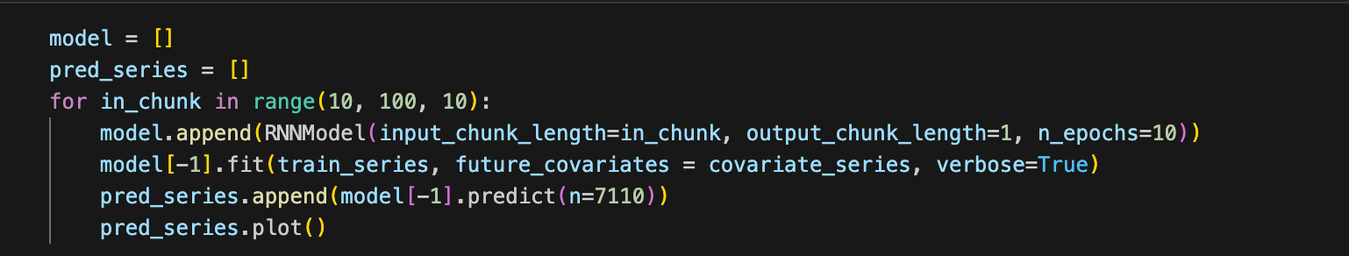

**02/12/2024**

I spent the class looking into Forecasting Anomaly Models. I learned that it works by utilizing multiple anomaly scorers that will be used to compare the actual and predicted time series in order to obtain an anomaly score. I noticed that the implementation requires labeled data. I am looking for an unsupervised alternative, but I am planning to label some of my data to see how well it performs in regard to anomaly detection. The main problem is that there are not many anomalies within my dataset. Half of the class looked through my dataset to see if there were any obvious anomalies that I could pick out and train my model on.

Here is the function information I found for the implementation of this model:



**02/14/2024**

I spent half of my class looking through my time series and was able to come across a time series with an anomaly segment. I spent the other half of the class looking through the documentation for the Forecasting Anomaly Model in the Darts Library to see the format that the labels have to be in. Concurrently, I am still manually finding good hyperparameter values with the code I wrote on Friday.